**ASSIGNMENT 2: NETWORKING COMMANDS AND WRITE THEIR OUTPUT**

**Submitted by : Sanjukta Dutta**

**PING:**

**OTHER IP IN NETWORK: OUTPUT IN WINDOWS**

C:\Windows\system32>ping 192.168.0.135

Pinging 192.168.0.135 with 32 bytes of data:

Reply from 192.168.0.135: bytes=32 time=10ms TTL=128

Reply from 192.168.0.135: bytes=32 time=6ms TTL=128

Reply from 192.168.0.135: bytes=32 time=6ms TTL=128

Reply from 192.168.0.135: bytes=32 time=6ms TTL=128

Ping statistics for 192.168.0.135:

Packets: Sent = 4, Received = 4, Lost = 0 (0% loss),

Approximate round trip times in milli-seconds:

Minimum = 6ms, Maximum = 10ms, Average = 7ms

============================================

**PING IN OTHER IP IN NETWORK: OUTPUT IN LINUX:**

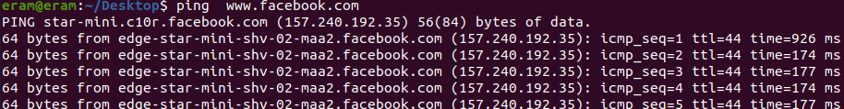

**PING IN LOCAL HOST: OUTPUT**

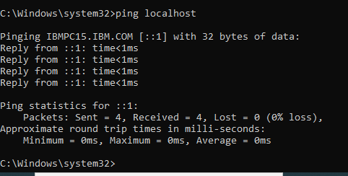

**PING WITH IP ADDRESS IN LOCALHOST:**

Pinging 192.168.0.111 with 32 bytes of data:

Reply from 192.168.0.111: bytes=32 time<1ms TTL=128

Reply from 192.168.0.111: bytes=32 time<1ms TTL=128

Reply from 192.168.0.111: bytes=32 time<1ms TTL=128

Reply from 192.168.0.111: bytes=32 time<1ms TTL=128

Ping statistics for 192.168.0.111:

Packets: Sent = 4, Received = 4, Lost = 0 (0% loss),

Approximate round trip times in milli-seconds: Minimum = 0ms, Maximum = 0ms, Average = 0ms.

**Tracert in windows:**

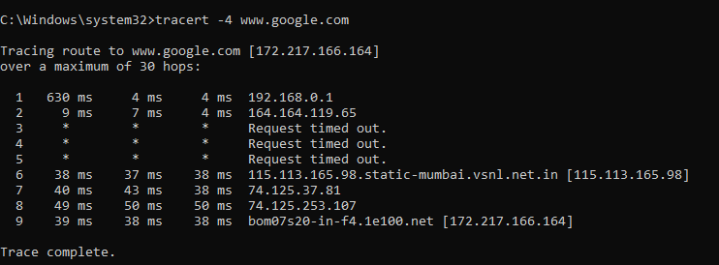

**Traceroute in linux:**

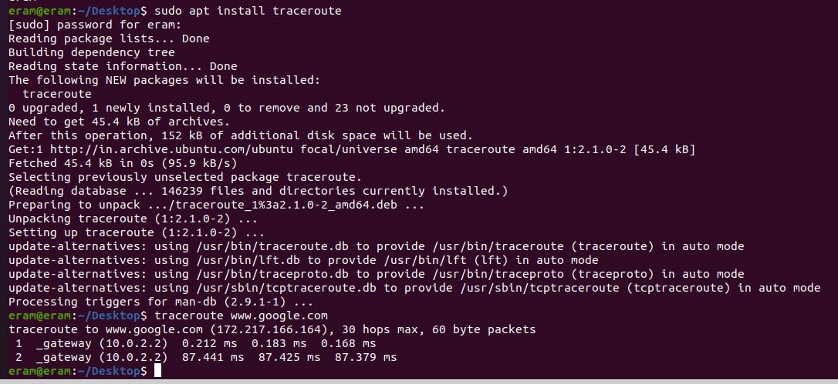

**HOSTNAME IN LINUX:**



**HOSTNAME IN WINDOWS:**

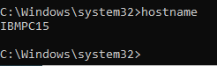

**NETSTAT WITH CMD IN WINDOWS:**

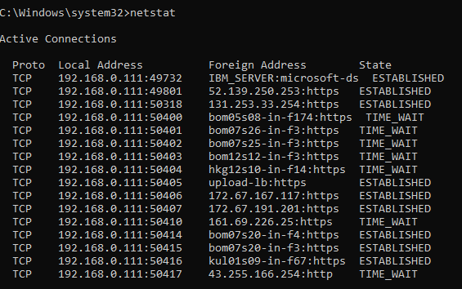

**Netstat command with cmd in windows:**

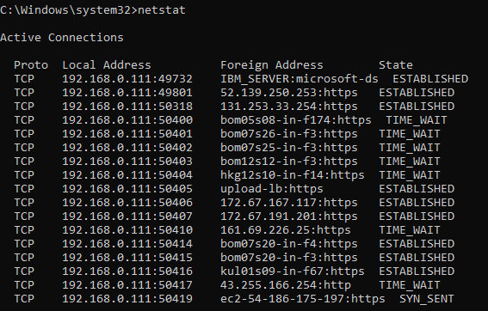

**Netstat in linux output:**

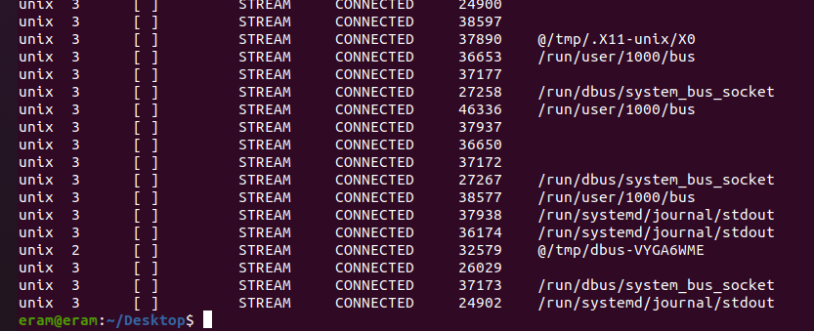

**Netstat –t command in window:**

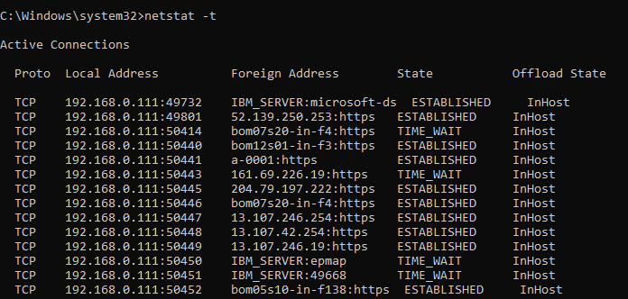

**Netstat –t command in linux:**

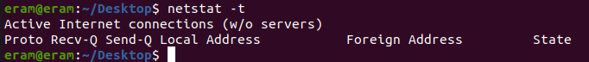

**Netstat -s –t command in window:**

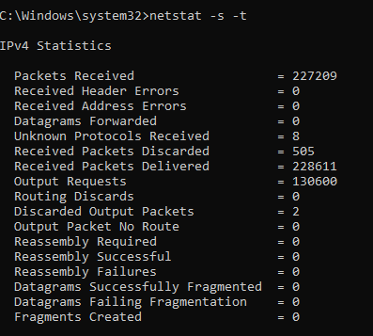

To be continued…

NETSTAT –T CMPLETED

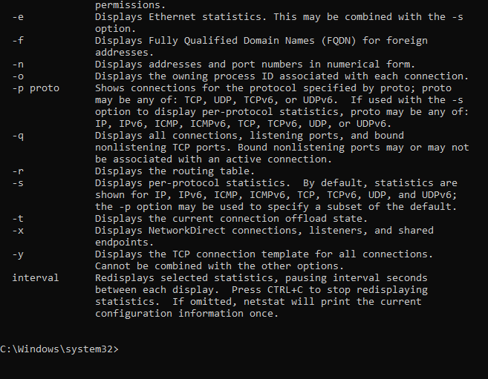

**netstat –i command in windows:**

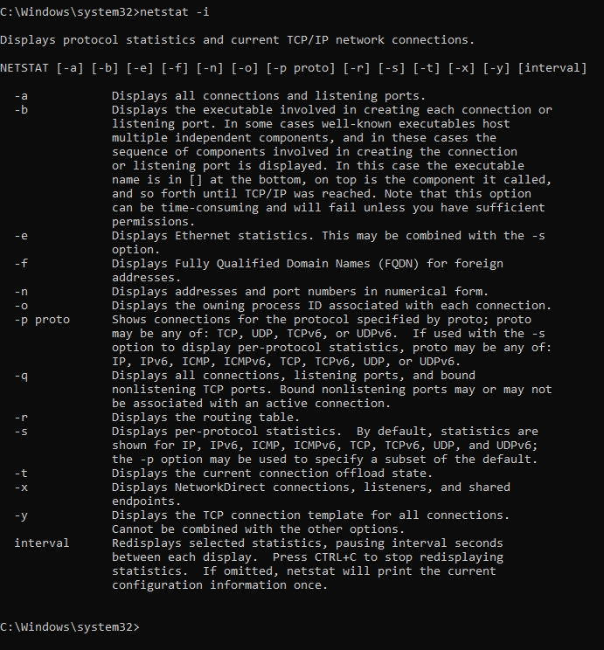

**netstat –i command in linux:**

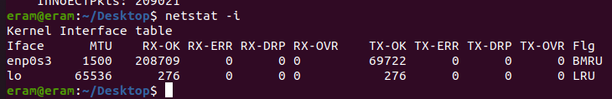

**Ifconfig in linux:**

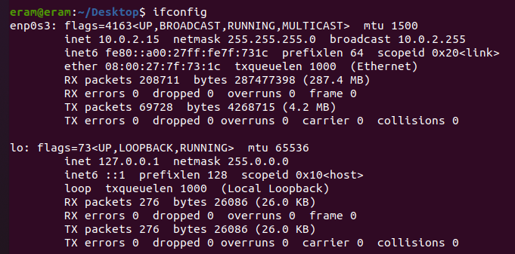

**Ipconfig in windows:**

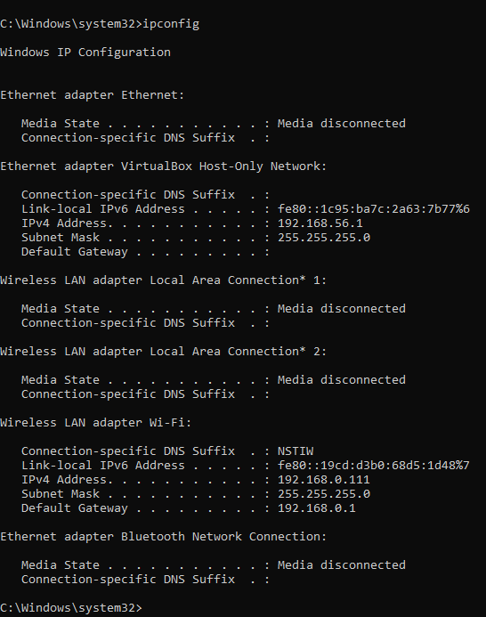

**6.who input in windows:**

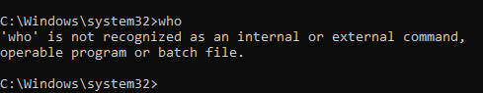

**who input in linux:**



**Command whoami in windows:**

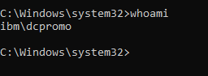

**Command whoami in linux:**



**Nmap in windows:**

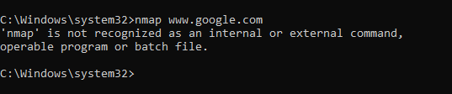

**Nmap in linux:**

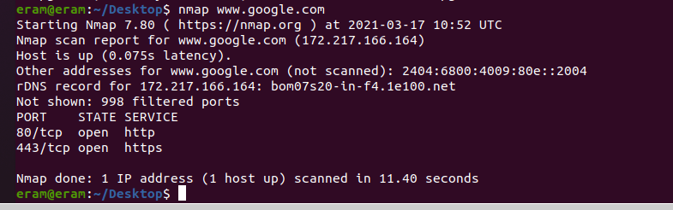

**Tcpdump command output in windows:**

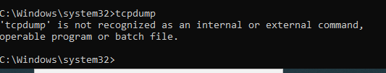

**Tcpdump command output in linux:**

